
Performance Management System


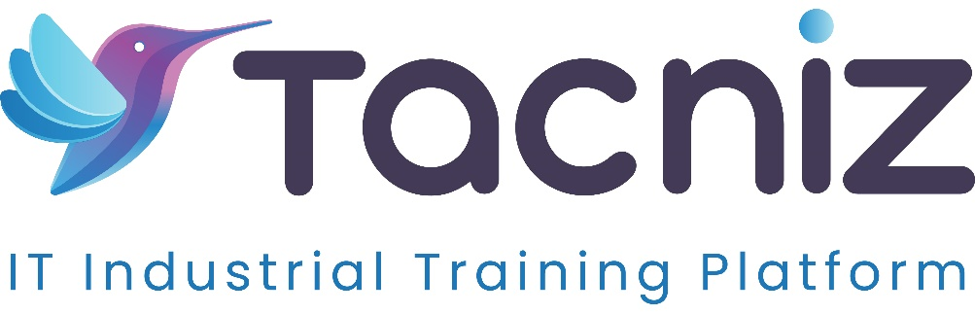

Problem Statement
Managing employee performance, tracking goals, and providing timely feedback can be challenging for organizations, particularly in large or distributed teams. Traditional performance evaluation methods are often inefficient, leading to unclear goals, delayed feedback, and misaligned expectations. A cloud-based performance management system is needed to streamline the process, enabling HR teams and managers to set goals, track progress, and conduct evaluations in real-time.

Project Type
- Type: HR Performance Management System
- Category: Goal Tracking, Performance Evaluations, Feedback System

Industry Area
- Industry: Corporate, IT, Education, Healthcare
- Relevant Sectors: HR Management, Talent Management, Workforce Development

Software Expertise Required
- Frontend Development: HTML, CSS, JavaScript (React, Vue, or Angular) for building user interfaces that allow employees and managers to set goals, monitor performance, and give feedback.
- Backend Development: Node.js / Python (Django/Flask) for tracking performance metrics, managing goal data, and storing evaluations and feedback securely in the cloud.
- Cloud Integration: AWS, Google Cloud, or Azure for managing user data, performance logs, and evaluations, ensuring scalability and real-time access.
- Data Analytics and Reporting: Tools for generating performance reports, tracking progress on individual and team goals, and identifying performance trends.
- Mobile App Development (Optional): React Native or Flutter to create a mobile app for goal tracking, real-time feedback, and performance reviews on the go.
- Security and Privacy: SSL/TLS encryption for secure data transmission, role-based access control, and compliance with data privacy regulations to protect sensitive employee performance data.

Use Cases
- HR Teams: Manage and track employee performance, automate performance evaluations, and analyze workforce performance data to guide talent management strategies.
- Managers: Set individual and team goals, monitor employee progress, and provide real-time feedback and coaching to align performance with organizational objectives.
- Employees: View personal goals, track progress, receive feedback, and participate in performance reviews, gaining a clearer understanding of their performance and growth opportunities.

Expected Outcomes
- Streamlined Performance Evaluations: HR teams and managers can conduct regular performance reviews, track employee progress, and provide feedback efficiently, all within one platform.
- Goal Alignment: Employees can set individual and team goals that align with organizational objectives, ensuring everyone is working toward the same targets.
- Real-Time Feedback: Managers can provide ongoing feedback in real time, helping employees course-correct and improve their performance continuously.
- Transparency and Accountability: Employees have full visibility into their goals and performance metrics, creating a transparent process for evaluations and promotions.

Key Features
- Goal Setting and Tracking: Employees and managers can set both individual and team goals, with the ability to track progress in real-time and make adjustments as needed.
- Performance Reviews: The system facilitates regular performance evaluations, allowing managers to review employee performance, provide feedback, and assign ratings based on predefined metrics.
- Real-Time Feedback: Managers can provide real-time feedback on employee performance, encouraging ongoing improvement and development.
- 360-Degree Feedback (Optional): The system can incorporate peer feedback, allowing employees to receive insights from co-workers, managers, and subordinates to foster a well-rounded evaluation process.
- Performance Analytics: HR teams and managers can generate reports on employee performance, track goal completion rates, and analyze trends in productivity and engagement.
- Notifications and Reminders: Automated notifications remind employees and managers to complete performance reviews, set goals, and provide feedback regularly.
- Mobile Access (Optional): Employees and managers can access the system via a mobile app, allowing them to track goals and provide feedback on the go.

Benefits
- Improved Goal Alignment: Employees and teams can set clear, measurable goals that align with organizational objectives, ensuring everyone is working toward the same outcomes.
- Increased Transparency: Employees have full visibility into their performance metrics, evaluations, and feedback, fostering a transparent and fair evaluation process.
- Real-Time Feedback: Continuous feedback helps employees improve their performance throughout the year, rather than waiting for annual reviews.
- Better Employee Engagement: Regular performance discussions and goal tracking enhance employee engagement, as they receive ongoing feedback and development opportunities.
- Data-Driven Decisions: Performance analytics provide HR teams and managers with insights to make informed decisions on promotions, raises, and workforce development strategies.
- Scalability: The cloud-based nature of the system allows it to scale easily with the organization, accommodating new employees, teams, and departments as they grow.

Project Duration
- Estimated Duration: 5-6 Months

